

HIGH MOOR MOTOR CLUB

Presents the

Keith A Wood Memorial Rally 2009

Sponsored by



AT
Three Sisters Race Circuit Nr Wigan
ON
Sunday 4th October 2009

Keith Wood Memorial Rally
Sponsored by
Gazzard Accounts
At Three Sisters Circuit

Supplementary Regulations

Announcement
High Moor Motor Club will promote a National B Permit Multi Use Keith Wood Memorial Rally sponsored by Roundabout Tyres on Sunday 4th October 2009 at Three Sisters Racing Circuit, MR 108/576007 ½
The Meeting will be ‘Held under the General Regulations of The Motor Sports Association Ltd (incorporating the provisions of the International Sporting Code of the FIA) and the Supplementary Regulations’, in addition to any other written instruction that the Organising Club may issue for the Event.

Authorisation
MSA Permit Number - TBA

Eligibility of Competitors
The event is open to: -
All fully elected members of the Organising club
Members of Clubs within ANWCC
Members of Clubs within SD34 MSG
All competitors must produce a valid Competition License and Club Membership Card and Championship Registration Card where applicable.
Membership of High Moor Motor Club is available – see entry form for details.

Championships
This event will be a round of the following championships: -
- PEC Tyres ANWCC Stage Rally Championship
- Slicks Tyres ANWCC Novice Stage Rally Championship
- ANWCC All Rounder’s Championship
- Tyres South Shore Ltd SD34 MSG Stage Rally Championship
- SD34 MSG Inter Club League Championship
  - The 3 Sisters Rally Challenge 2008

Programme
The Programme of the meeting will be as follows: -
Noise check opens at 09:59 hrs
Scrutineering opens at 07:15 hrs
Signing on opens at 07:30 hrs
First car starts at 10:00 hrs
Any competitor not signed on by 09:15 hrs may be excluded. Individual times for Scrutineering will be issued in the final instructions.

Event Format
The event will contain up to 12 stages with a mileage of approximately 24 miles. These stages will be timed to an accuracy of less than one minute in accordance with H195 Cars will start at 30-second intervals. This event will consist of 100 % tarmac stages.
The event will consist of four classes as follows: -
Class 1 Cars with engines up to and including 1300 cc
Class 2 Cars with engines 1301 and up to and including 1600 cc
Class 3 Cars with engines 1601 and up to and including 2000 cc
Class 4 Cars with engines 2001 cc and over.
All vehicles must comply with MSA Technical Regulations. Cars need not be taxed, but
current MOT certificates are required if applicable, together with MSA Log Book as per
H146. Cars with forced induction will have their capacity increased by 70% for classification.
A Sound Test will be carried out in conformity with H12 and C(b)24.
Your attention is drawn to: C(c)52-66, C(c)77-86 and C(c)87-100, MSA Vehicle Log Books
will also be required for inspection.
Your attention is drawn to C(e)9-14 and the regulations regarding permitted tyres. All
tyres contained with C(e)15 -16 are automatically authorised.

In view of environmental considerations, Anti-Lag systems must be disconnected.

Awards
1st Overall Driver / Co-Driver Keith A. Wood Memorial Trophy
2nd Overall Driver / Co-Driver An Award
1st In each Class Driver / Co-Driver An Award
2nd In each Class Driver / Co-Driver An Award
3rd In each Class Driver / Co-Driver An Award
1st Novice Crew Driver / Co-Driver An Award
1st Formula 1000 Driver / Co Driver An Award
A Novice Crew is one who has never won an overall or class award. No competitor may win more than one of the above awards. The awards will be presented at the venue following completion of the final results. Any competitor not at the presentation will not receive his/her award.

Entries
The entry list opens on publication of these regulations and closes on 26th September 2009. The entry fee will be charged at the following rates:
Entry received by last post 19th September 2009…………. £135.00
Entry received after 19th September 2009……….…….…... £145.00
The organisers reserve the right to impose a surcharge should there be any variation to the proposed charges.
It is the competitor’s responsibility to ensure that their entry is received by the due date. Any entries not paying the required fee will not receive paddock passes until required fees are paid.
All entries must be on the official entry form and accompanied by the appropriate fees. In the event of a cheque being returned by the bank as unpaid, the entry will be voided and the matter may be reported to the MSA.
The entry secretary to whom all entries must be sent to: -
Gary Heslop, 33 Acresfield Road, Middleton, Manchester, M24 2WT
Telephone 0161 643 0151 Mobile 07973 816965 email gary.heslop@btinternet.com

If you need to telephone any officials, please do so 18:00hrs - 21:00 hrs. (or your return call may be at 2.00 am, seriously)
All cheques to be made payable to High Moor Motor Club. Entries will be refunded up to the closing date less £ 20.00 for administration, provided that written notification is received prior to the closing date.
After the closing date, entries will be refunded at the discretion of the organisers. The maximum entry for the meeting will be 65, the minimum is 30, and the minimum per class is 5. Should any of the above minimum figures not be reached the organisers have the right to either cancel the meeting or amalgamate classes as necessary. Entries will be selected at the discretion of the organisers.

Officials

MSA STEWARD TBA
CLUB STEWARDS TBA
CLERK OF THE COURSE Gerry Morriss
ASST CLERK OF COURSE Matt Dickson
SCRUTINEERS Chris Mansley
Environmental Scrutineer Ian Johnson
CHIEF TIMEKEEPER Gerry Morriss
CHIEF MARSHAL James White
CHIEF MEDICAL OFFICER Keith Knowles
RESCUE SERVICES Extractor Rescue
RECOVERY SERVICES Extractor
SAFETY OFFICER James White
SECRETARY OF MEETING Gerry Morriss
07967 830210 secretary@hmmc.co.uk

Results
Provisional results will be posted as soon as possible after each stage. Any protest must be lodged in accordance with C (d)45-59. Competitors will be supplied with time cards and details of all special stages at signing on.
Servicing will be permitted only in the designated service areas.

Identification
Competitors will be identified by competition numbers, in accordance with C(b)6, supplied by
the Competitor, to be fixed to each door prior to scrutineering.

Timing and Controls
All digital clocks will be set to BBC time. Competitors will start special stages when called to do so. The starting signal will be a manual directive. The event will be timed in accordance with Target Timing. (H152)
It is a competitor’s responsibility to ensure that his time card is completed correctly and handed in when instructed. Organisers times and mileage’s will be deemed correct and will not be subject to protests. Any adjustments caused by a timekeeper’s error must be made at the control in question. Special stage timing will be by digital clocks operated by Marshal’s under the control of a Chief Timekeeper; such timing will be to the last complete second. The organisers reserve the right to use other methods should any digital clock fail

Penalties
Penalties will be as printed in the appropriate section of the MSA General regulations except as modified below
Exceeding Maximum Lateness or Cumulative Maximum Lateness Exclusion
Not complying with a requirement of the road book. Stage maximum.
Not attempting or being ready to attempt a stage when instructed to do so. Stage maximum.
For each minute over target time in a service area.
First 5 Minutes No penalty
Over 5 minutes Exclusion
Excessive sound. Cars which in the opinion of the Clerk Of The Course
with the assistance of the Environmental Scrutineer has excessive noise levels. Exclusion
Failure to follow the instruction of an official
First Offence Warning
Thereafter Exclusion
Repeated misbehaviour of Service crew. Exclusion
Misuse of SOS and / or OK boards Exclusion
Unauthorised testing or practice. Exclusion
Causing an obstruction. Stage Maximum

Maximum Permitted Lateness
Reference H200 Maximum time allowed will be 5 minutes.
Reference H201 Maximum cumulative lateness will be 15 minutes

Fuel
The use of FIA specification fuel (FIA Appendix J, Article 252, Article 9) will be permitted for use on this event. Competitors using fuel that does not comply with the MSA definition of pump fuel (Section P) must display an orange disk as per regulation C(b)19. Competitors are reminded that where entered in a championship that has not specified the use of FIA specification fuel, the use
of such fuel might affect their championship eligibility. If you are in doubt you should check with the championship co-ordinator.

Other Notices
Petrol is not available at the venue.
Any notice signed by the Clerk of the Course or the Secretary of the Meeting will have the same authority as these S.R.’s.
Final instructions will be posted in the week before the event to the address submitted on your entry form
Competitors must complete a damage declaration form in accordance with H248-249 K35.4 Competitors who retire are reminded that failure to submit this form to the Secretary of the Meeting within 72 hours of the finish may be Fined up to £ 100
Competitors causing damage to any third party property will be liable for any excess High Moor Motor Club has to pay to the MSA insurers and also any cost that is not covered by the Insurers.

Judges of Fact
The facts to be judged will be as listed in H140 All Named officials in these SR’s & Marshals and Officials recorded on the Official notice board will be deemed to have been appointed as Judges of Fact.

PLEASE NOTE:
INDEMNIFICATION FORM (SIGNED) TO BE RETURNED WITH COMPETITORS ENTRY FORM………..THANK YOU.



PEC
TYRES
DRUID GARAGE
DRUID
CORWEN
DENBIGHSHIRE
01490 460469 or 01490 460529
THE MAIN DISTRIBUTORS AND DEVELOPERS OF
KUMHO RALLY TYRES
We also stock Dunlop, Michelin, Pirelli and Fast tyres

On-event service at most ANWCC Championship events
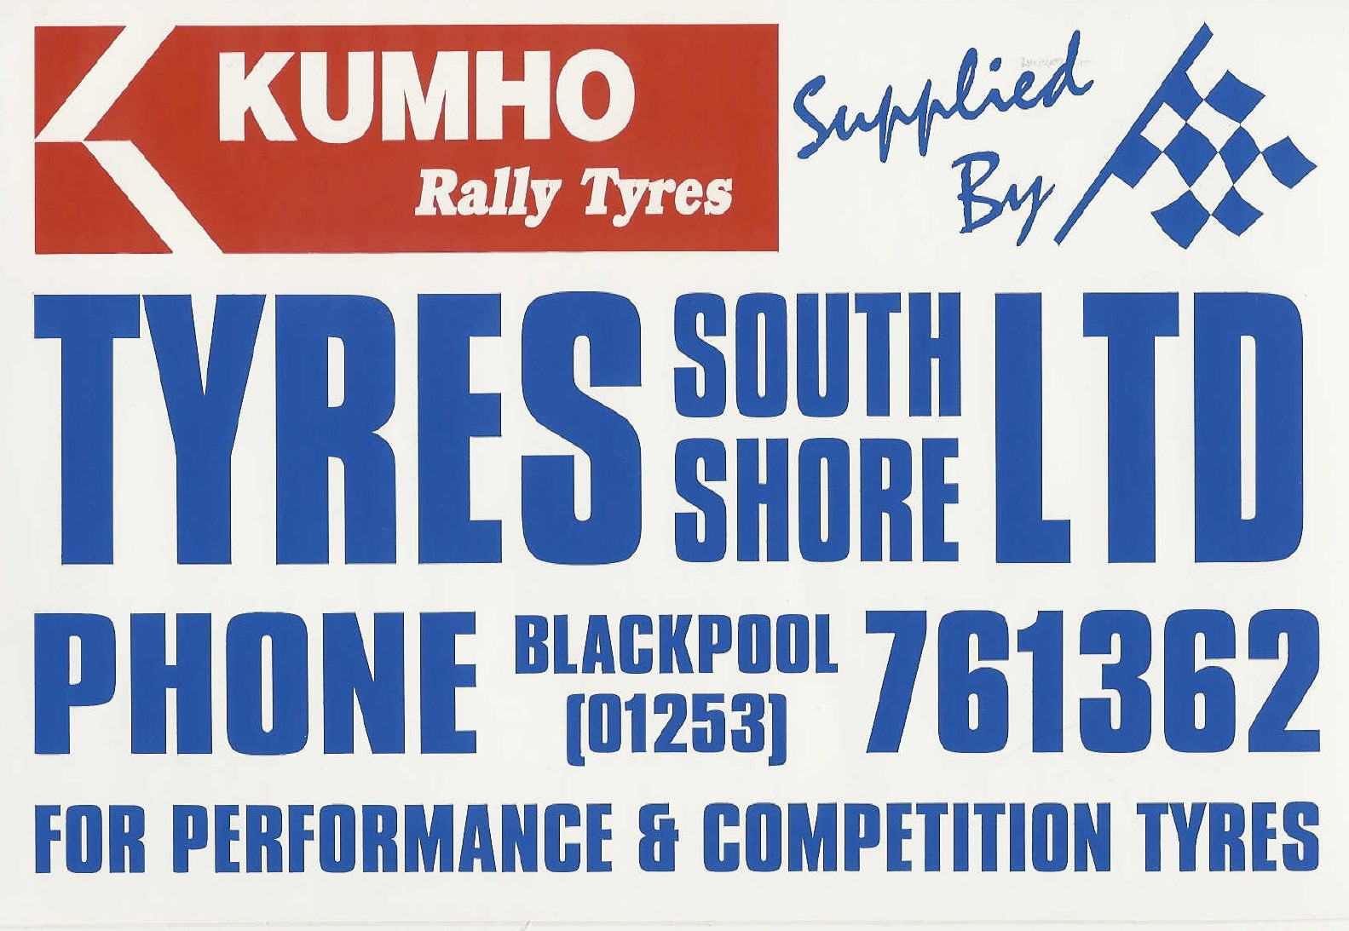

KEITH A WOOD MEMORIAL RALLY
Sunday 4th October 2009
ENTRY FORM
PLEASE USE BLOCK CAPITALS
DRIVER |  | Co – DRIVER
NAME |  | NAME
ADDRESS |  | ADDRESS
POSTCODE |  | POSTCODE
TELEPHONE |  | TELEPHONE
LICENCE No. |  | LICENCE No.
CLUB |  | CLUB
E-MAIL |  | E-MAIL
NOVICE | YES NO | NOVICE | YES NO
CAR |  | CHAMPIONSHIPS
MAKE |  | ANWCC F1000
MODEL |  | ANWCC STAGE CHAMPIONSHIP
REG. NUMBER |  | ANWCC NOVICE STAGE CHAMPIONSHIP
COLOUR |  | ANWCC LADIES CHAMPIONSHIP
CAPACITY (CC) |  | SD34 STAGE CHAMPIONSHIP
CLASS ENTERED
SEEDING INFORMATION
DATE | EVENT |  | CLASS | OVERALL
PERSON TO BE CONTACTED IN THE EVENT OF AN ACCIDENT
NAME
ADDRESS
TELEPHONE
FEES - Cheques made payable to High Moor M.C.
ENTRY FEE | On or before 19th September 2009 | £135.00
 | After 19th September 2009 | £145.00
HMMC MEMBERSHIP | Driver | £5.00
HMMC MEMBERSHIP | Co Driver | £5.00
TOTAL ENCLOSED |  |  | £

Indemnification

I have read the supplementary regulations issued for this event and agree to be bound by them and the general regulations of the Motor Sports Association Ltd. In consideration of the acceptance. of this entry or of being permitted to take part in this, event I agree to save harmless and keep indemnified the Motor Sports Association Ltd., such person, persons or body as may be authorised by the MSA Ltd. to promote or organise this event and their respective officials, servants representatives and agents from and against alt actions, claims, costs, expenses and demands in respect of death or injury to myself, however caused arising out of or in connection with this entry or taking part in this event, and not withstanding that the same may have been contributed to or occasioned by the negligence of said bodies, their officials servants representatives or agents.
Furthermore, in respect of any parts of this event on ground where third party insurance is not required by law this agreement shall in addition to the parties named above extend to all and any other competitor's) and their servants and agents and to all actions, claims, costs, expenses and demands in respect of loss or damage to the person or property of myself, my driver, or mechanic(s) I. also agree to pay any insurance excess in respect of any claim that may be made on my behalf by the organisers

MY AGE IS____________________________________________________________________

(If applicable state over 17 years)

I declare that to the best of my belief the driver(s) possess (es) the standard of competence necessary for an event of the type to which the entry relates and that the vehicle entered is suitable and road worthy for the event having regard to the course and the speeds which will be reached
I understand that should I at the time of the event be suffering from any disability whether permanent, temporary or otherwise which is likely to affect prejudicially my normal control of the vehicle I may not take part unless I have declared such disability to the MSA Ltd who have, following such declaration issued a License which permits me to do so
If driver is under 18 years of age this entry must be countersigned by a parent/guardian -

Drivers  Signature | Co Drivers  Signature
Age if under 18 | Age if under 18
Signature of parent / guardian | Signature of parent / guardian
Name & Address | Name & Address

PLEASE NOTE: INDEMNIFICATION FORM (SIGNED) TO BE RETURNED WITH COMPETITORS ENTRY FORM………..THANK YOU.

SPECIALISTS IN ALLOY WHEELS

& PERFORMANCE TYRES

All at competitive prices

ROUNDABOUT TYRES provide an experienced and established service for use by customers living in Oldham and Rochdale. We supply Alloy Wheels & Tyres to all areas around Manchester, and other areas across the Nth.West .
Services also provided:
MOT TESTING
(by appointment)
REPLACEMENT/NEW TYRES
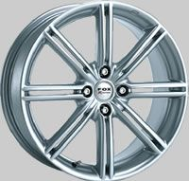
WHEEL BALANCING/TRACKING
4 WHEEL ALIGNMENT
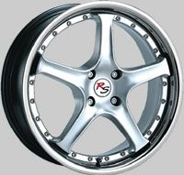
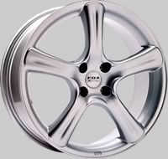
PUNCTURE REPAIRS

FOX O.Z
WHEELS WHEELS
For a more detailed list of the Alloy Wheels (+ some Wheel/Tyre packages) that we currently have for sale, which changes on a regular basis.
Please call in, ring us, or take a look at our Website :
www.roundabouttyresshaw.co.uk
ROUNDABOUT TYRES
Crompton Way, Shaw, Oldham, Lancs. OL2 7AF.

Tel : 01706 840338

Opening Hours :
Monday – Friday : 9am – 6pm ;
Saturday : 9am – 2pm .

